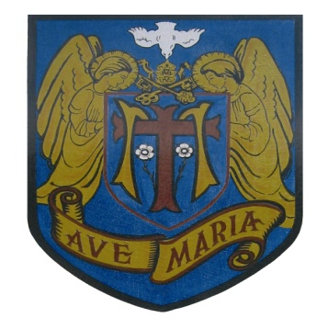
ST. MARY’S CATHOLIC PRIMARY SCHOOL

Headteacher: Mrs N Grant Bsc (Hons)
Telephone: 01924 472273
Email: office@stmarysbatley.co.uk Website: http://www.stmarysbatley.co.uk

29th May 2020

Confirmation of a phased re-opening of St Mary’s Catholic Primary School

Dear Parents/carers

The Government briefing on May 28th confirmed that the 5 measures had been achieved and therefore schools should move forward with their plans for a phased reopening for some year groups from Monday 1st June.

Therefore, according to St Mary’s plan you received last week, Governors have approved that we will move to admit SOME groups of pupils as detailed below. (Please note only the children whose parents confirmed a request for a place by 4pm Thursday 21st May will be accepted).

Please note all start and end times are subject to change once we have reopened and assessed the health and safety of these arrangements.

Monday 1st June (if you have booked a place according to your rota)
Keyworkers/vulnerable. 8.55am start and 3pm finish.

Wednesday 3rd June (if you have previously confirmed your child would return)
Reception/Nursery 9.15am start and 2.45pm finish. (12 noon for nursery)
Year 6 9.30am start and 3.15pm finish

Thursday 4th June (if you have previously confirmed your child would return)
Year 1 9.10am start and 3pm finish

School will end each Friday at 12.30pm for Reception and Yr. 1 and 12.50pm for Key workers and Yr. 6
Staff will be present to guide you to where you should stand and queue. A gentle reminder to the school plan which states that children may be encouraged into school but no physical guidance/hand holding will be possible. Parents will remain at the entrances outside the school fencing.
If you wish to change your mind and not send your child to school at the current time, then please ring/email the school office to confirm this decision to comply with our safeguarding and attendance procedures. If you do now want a place, we require a 2 week notice period to alter staffing and amend our groupings.

Uniform should be worn where possible (please do not buy new for the last few weeks), and footwear appropriate for playing out as we are not using cloakrooms for changing. Coats will be placed on the back of a child’s chair on arrival.

Packed lunches will be available free from the school kitchen for Reception, Yr 1 and any families in receipt of Free School Meals. Parent pay payments should be made for all other pupils. Alternatively, all children may bring their own lunch from home.

Please ensure your child brings only their own water bottle and packed lunch (if applicable) from home. NO school bags, toys (including balls) or equipment are permitted.

There will be a zero tolerance of any behaviour that puts any staff member or another child at risk. Any deliberate coughing/spitting or poor behaviour needing physical intervention will result in parents being asked to collect their child immediately and their place withdrawn until September.

Please note school will not administer any medicine during the school day (except inhalers) so do not send your child if they are suffering from any COVID symptoms especially high temperature and/or a cough, headache, earache etc. as we will not administer pain relief such as calpol or ibuprofen.

We will endeavour to settle your child(ren) back into school and we know you understand that unfortunately their school day will be very different to the one they remember.

Please contact school by telephone or by email if you have any questions about our phased reopening.

Yours sincerely

Mrs N Grant

