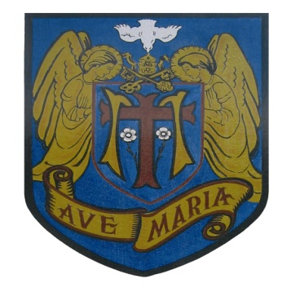
ST. MARY’S CATHOLIC PRIMARY SCHOOL
Headteacher: Mrs N Grant Bsc (Hons)
UPTON STREET, BATLEY, WEST YORKSHIRE WF17 8PH
Telephone: 01924 472273
Email: office@stmarysbatley.co.uk Diocese of Leeds - Kirklees Education Service

Fantastic Fridays

From March 2018 our cook Maggie would like to offer a ‘Fantastic Friday’ lunch. Children who normally have school dinners will automatically partake. However if your child normally has sandwiches but would like to join in please complete the attached slip and pass to the school office.

Friday Meals are Fish Fingers and chips, with Peas, Chilli Con Carne & Rice or chilli Wraps. Jacket potatoes are also available with assorted fillings. Desserts are ice cream roll, lemon drizzle cake, assorted biscuits or yoghurts.

If this is something your child would like to try we would ask that they sign up for the whole half term (Friday 2nd March – Friday 23rd March) 4 weeks.

We cannot allow pupils to swap from dinners to sandwiches each week.

The cost of this event will be £2.12 per week so the cost for the whole half term will be £8.48 unless your child is eligible for universal free school meals (Reception – Y2) or is entitled to free school meals.

Please detatch this section and return to the school office by Monday 12th February 2018. Please retain the top section of the letter for your information.

Please circle as applicable.

Name of child……………………………………………………………………………….

Class ……………………………………………………………………..

My child is eligible for universal free school meals (Reception – Y2) in September and would like to try Fantastic Fridays for the whole half term.

My child/ren is eligible for free school meals and would like to try Fantastic Fridays for the whole half term.

My child/ren would like to try Fantastic Fridays and I will pay £8.48 on parentpay.

